**Object Oriented Programming**

**Lab Report**

**Lab04**



|  |  |
| --- | --- |
| Group Members Name & Reg #: | **Muhammad Haris Irfan**  **(FA18-BCE-090)** |
|  |  |
| Class | Object Oriented Programming CSC241 (**BCE-4B**) |
| Instructor’s Name | Maam Amber Madeeha Zeb |

**In Lab Tasks**

**5.1 Task 1:**

**Code the example of complex class given above and include the functions for addition, subtraction and multiplication of objects of complex class and return the object containing result. Test all the functions in main.**

**Solution:**The code is given below,

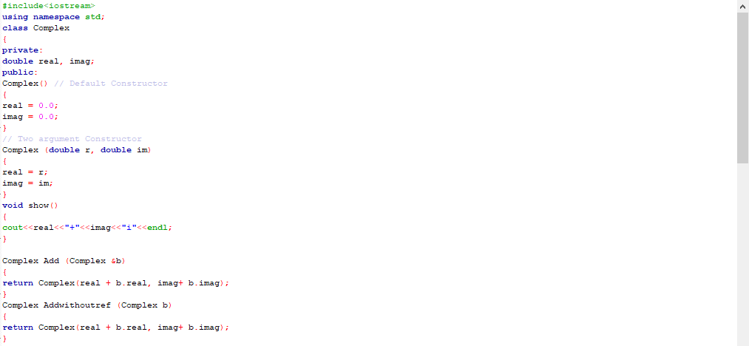

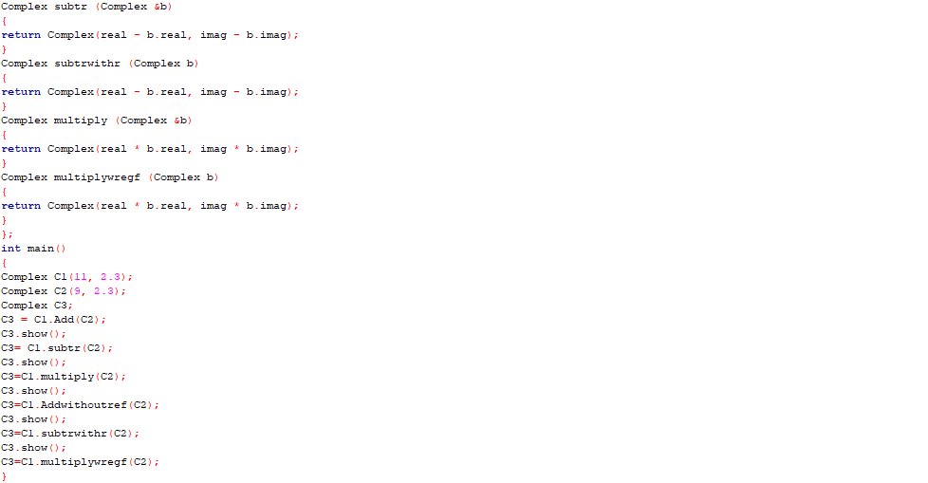

**Console Output is shown below.**

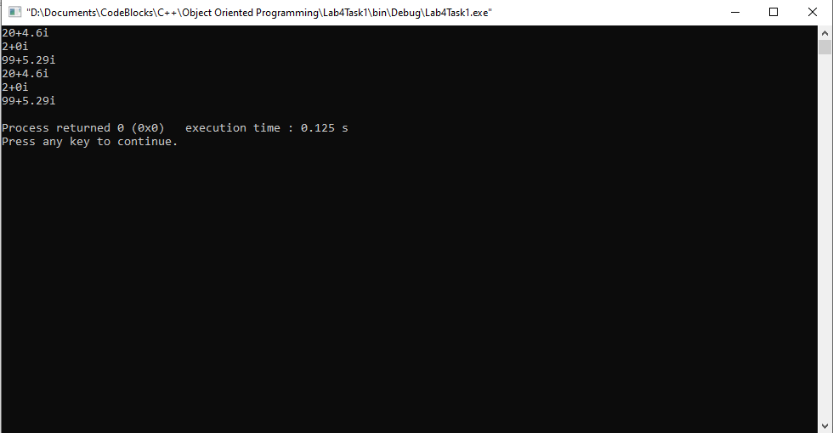

____________________________

**5.2 Task:2**

**Modify the above task such that; define the member function show() outside the class.**

Solution:

I am attaching my code below,

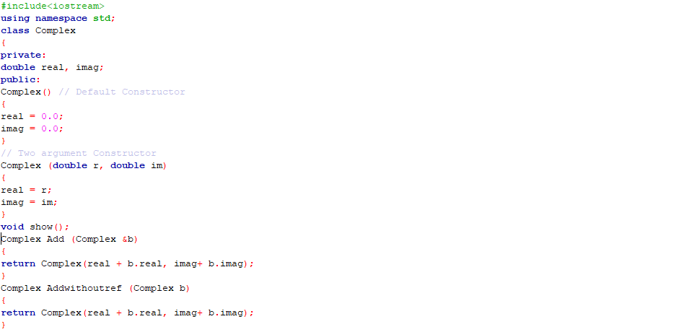

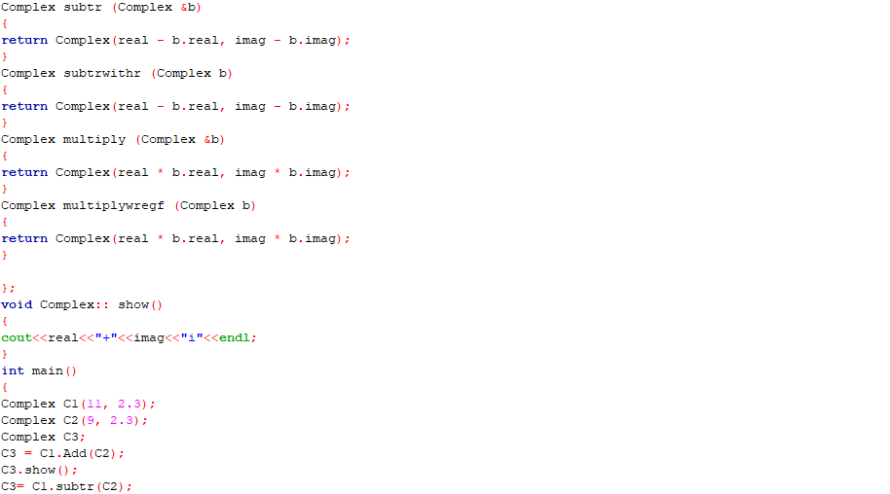

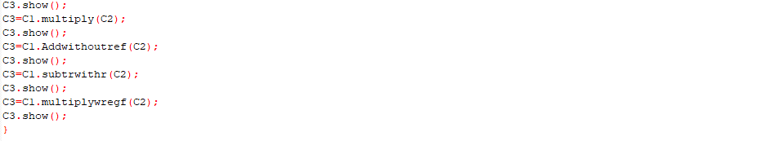

The result for this program is shown below,

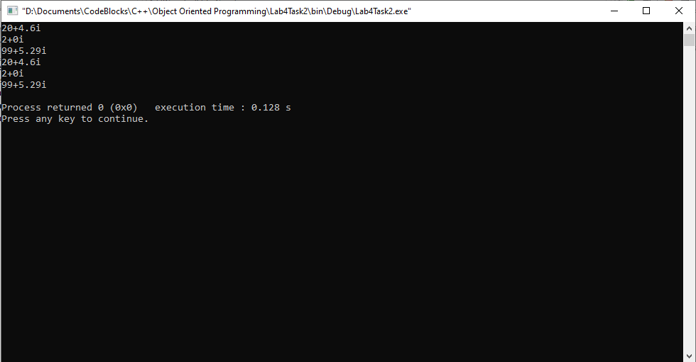

_____________________________

**5.3 Task:3**

**Modify the task (5.1) by defining all the member functions outside the class definition.**

Solution:

I am attaching my code below,

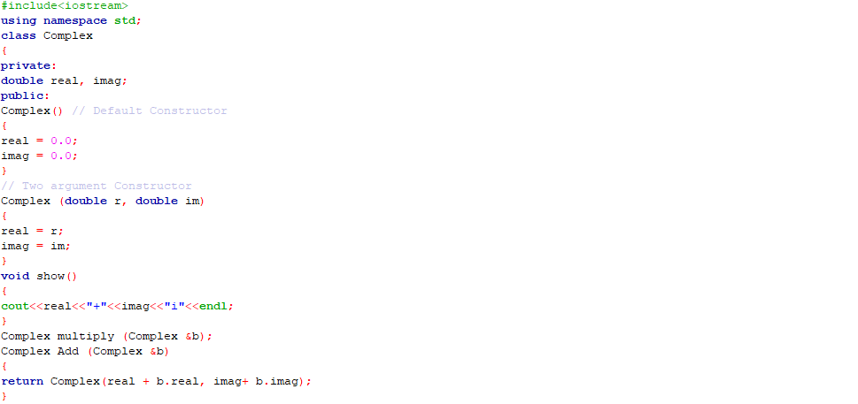

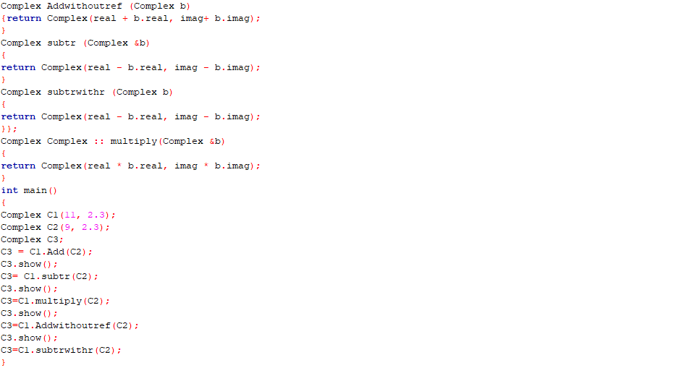

The result for this program is shown below,

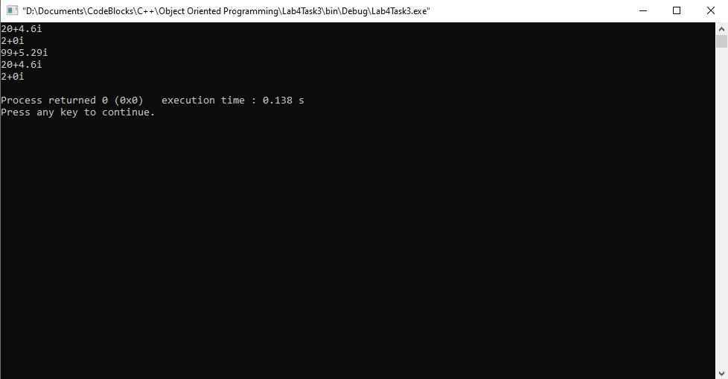

_____________________________

**5.4 Task:4**

**Test the distance class example given above.**

Solution:

I am attaching my code below,

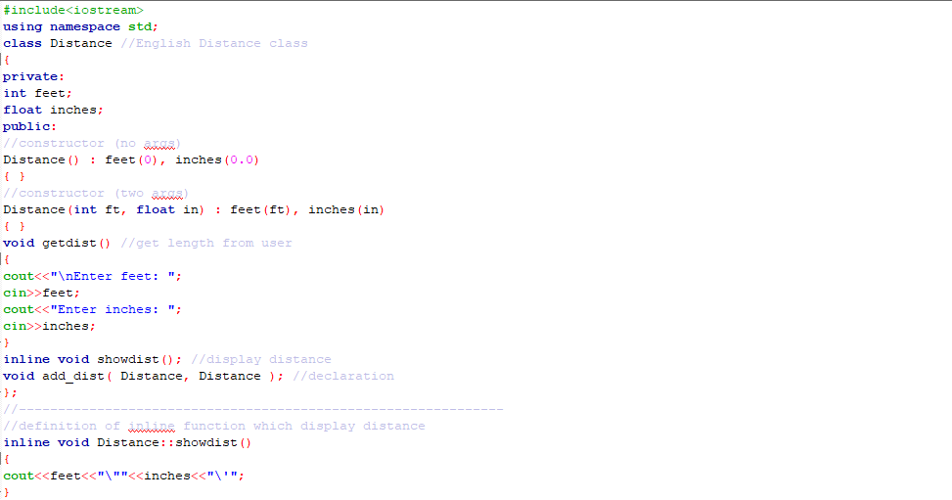

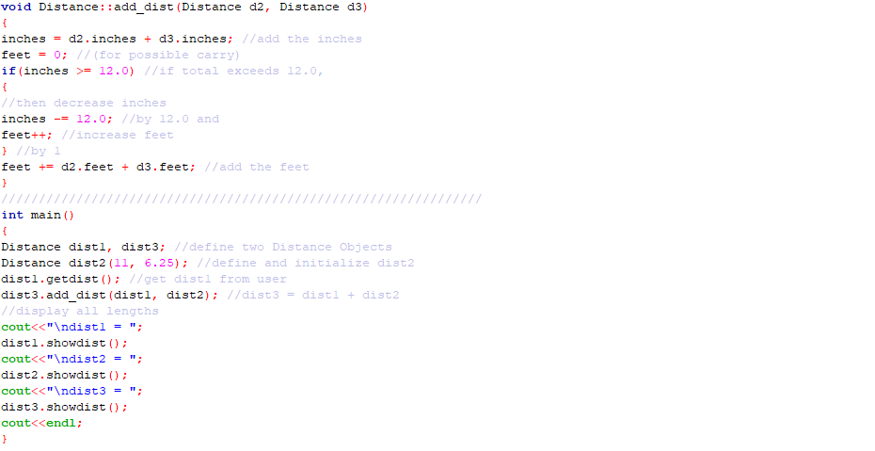

The result for this program is shown below,

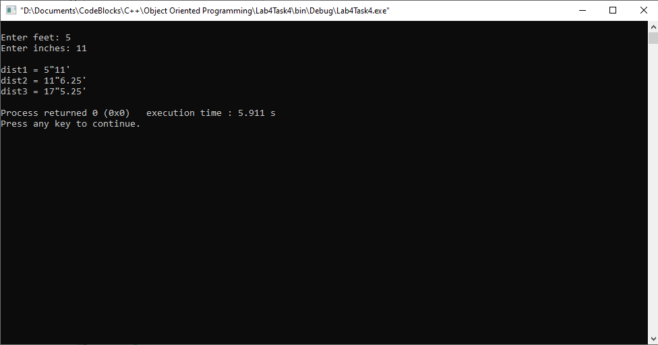

_____________________________

POST LAB

6.1 Question 1:

**Modify the Distance class example of lab task (5.4) by including functions for subtraction and multiplication of distance class objects like addition.**

Solution:

I am attaching my code below,

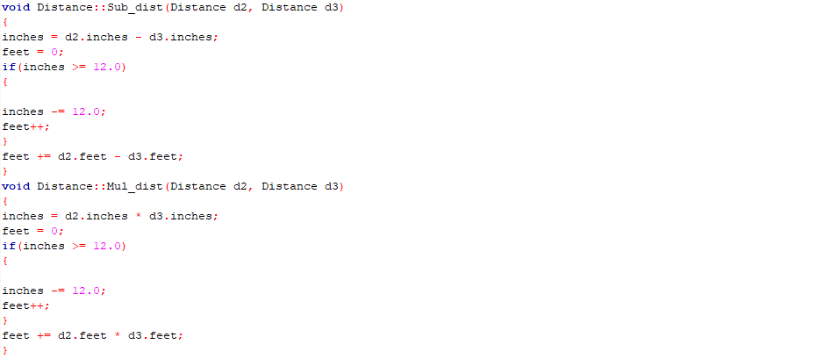

The result for this program is shown below,

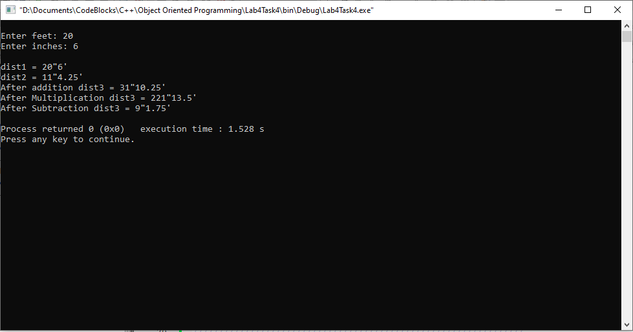

______THE END________

_______________